**K L UNIVERSITY**

**COMPUTER SCIENCE & ENGINEERING DEPARTMENT**

**GUESSING WORD GAME IN PYTHON**

Submitted by:

2010030024 – BOPPANA VEGESH SAI

2010030031– CH. VARUN

2010030083 – K.SAI ANIRUDH

2010030452 – FAUZAAN



**K L UNIVERSITY**

Green fields, Vaddeswaram – 522502

Guntur Dt., AP, India.

**INDEX**

|  |  |
| --- | --- |
| **S.NO** | **TOPIC** |
| 1 | Introduction |
| 2 | Problem Statement |
| 3 | Objective |
| 4 | Literature Survey |
| 5 | Model |
| 6 | Flow chart |
| 7 | Output |
| 8 | Conclusion |
| 9 | GitHub commits |

**1**

**Introduction**

* There will be given some letters in some order and we need to guess that word and arrange the letters in proper order.

**PROBLEM STATEMENT**

* Create a guessing game that told you if the number you put in was too high or too low and then congratulated you when the number was correct.

* To use Crocodile Clips correctly and learn about the different things (edit boxes, inputs) you use.

* To make sure your guessing game was correctly working through the whole thing.

* To have a correct loop that worked in the right way.

**OBJECTIVE**

The Objective of **the ‘Guessing Game’ was to create a flowchart that you would enter your guess in, and it would tell you if you’re answer should be higher, lower or if it’s spot on. We had to include variables, inputs and outputs.**

**How it is better than the current system?**  
They use the context to guess the meaning of English words. It can be a tool to introduce, review, and reinforce new vocabulary to the students. It can make the students to be more memorizing the words.

**LITERATURE SURVEY**

**DATASETS**

WE MADE OUR OWN DATASET.

**MODEL**

NO MODELS USED IN OUR PROJECT.

**FLOWCHART**

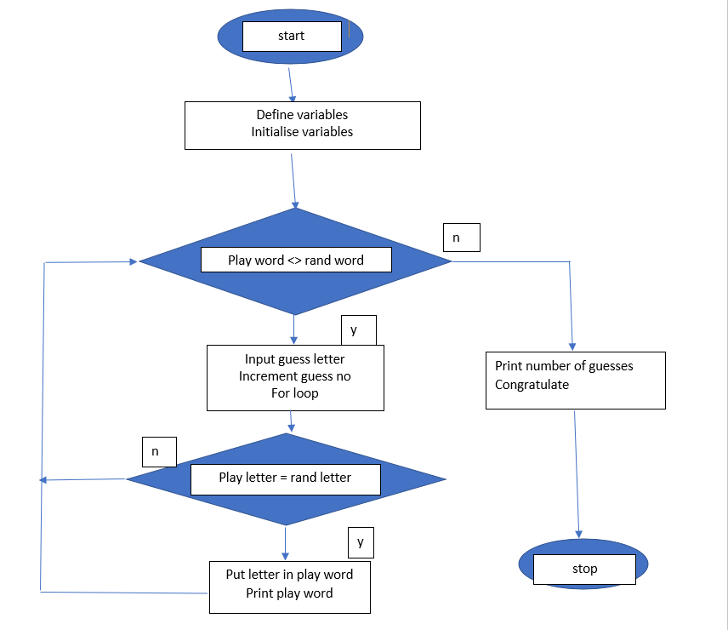

**TECHNIQUES**

NO TECHNIQUES USED**.**

**PACKAGES REQUIRED**

Django: - Django itself is also a normal Python package. This means that you can take existing Python packages or Django apps and compose them into your own web project. You only need to write the parts that make your project unique.

OS: - The OS module in Python provides functions for interacting with the operating system. OS comes under Python's standard utility modules. This module provides a portable way of using operating system-dependent functionality.

**OUTPUT**

**CONCLUSION**

The results showed that the students' speaking skills improved after learning with guessing games. The speaking skills that improved significantly are pronunciation, vocabulary, and fluency. Grammar and comprehension, on the other hand, improved but not significantly.

**GITHUB COMMITS**

